1. **Create docker file for nginx:**

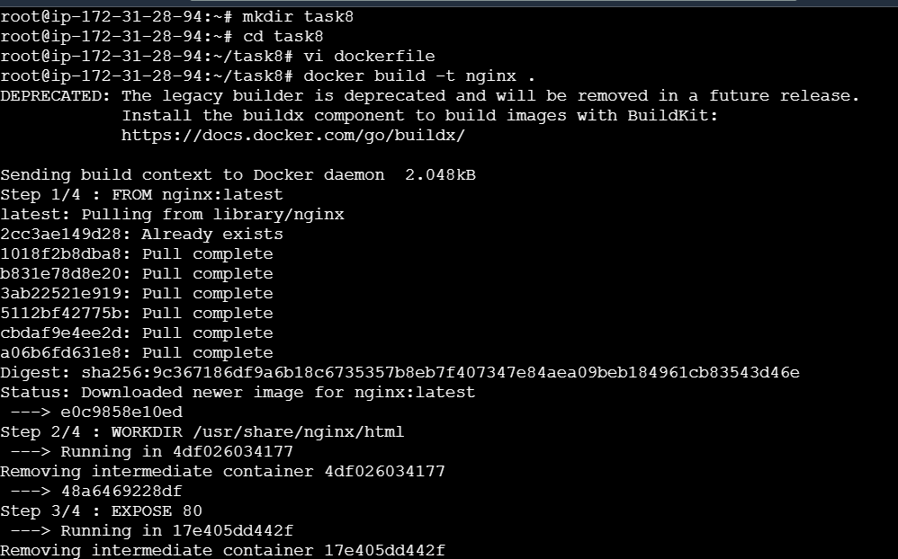

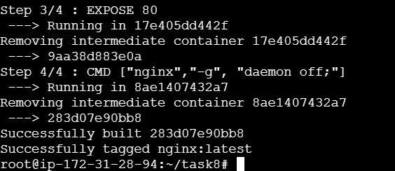

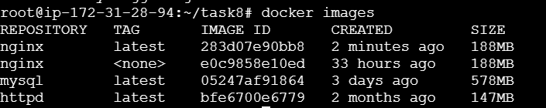

1. **Run custom docker images:**

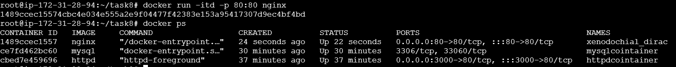

1. **Docker compose installation:**

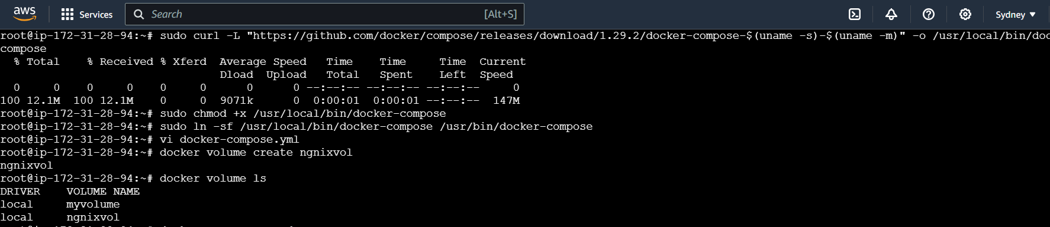

**Docker compose file:**

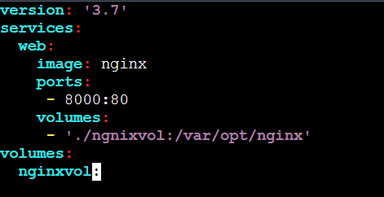

**Nginixvol created:**

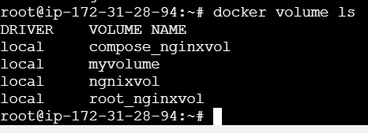

**Execute the docker compose file:**

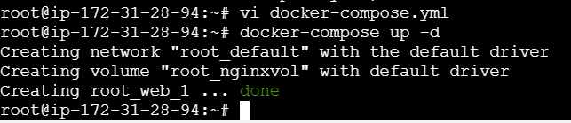



**Dockerhub login:**

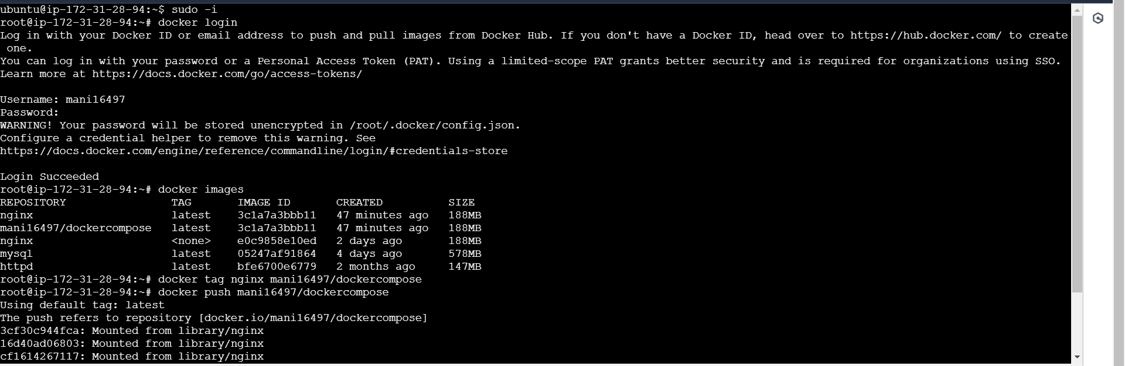

**Push an image to docker hub repository:**

